Project Journal

Machine Vision-Based Underwater Anti-Backscatter Lighting System.

Sidharth Shanmugam.

Table of Contents

W/B 30-10-2023 5

Initial supervision meeting & high-level objectives 5

W/B 06-11-2023 7

Intro to real-time software [1] 7

Supervision meeting 7

W/B 13-11-2023 9

Porting to C codebase for performance benefits. 9

Digital image processing literature 9

Quick discussion with Ben 10

Extracting Katie’s code from the Pi 10

Playing around with blob detection and example GoPro backscatter footage 11

W/B 20-11-2023 21

Literature Gathering 21

Supervision Meeting 21

W/B 27-11-2923 22

Literature Review – The Bubble Box: Towards an Automated Visual Sensor for 3D Analysis and Characterization of Marine Gas Release Sites [3] 22

Introduction 22

Summary 22

Key Concepts and Terminology 22

Related Works 23

Methodology 24

Findings 26

Discussion and Conclusion 26

Literature Review – Gas Bubble Shape Measurement and Analysis [8] 27

Introduction 27

Summary 28

Key Concepts and Terminology 29

Related Works 29

Methodology 29

Findings 31

Discussion and Conclusion 32

W/B 04-12-2023 34

Supervision meeting 34

W/B 22-01-2023 36

Working with real-time constraints: Docker vs Jailhouse 36

Preparing Pi for remote connections within the university network 37

Literature Review – Automated gas bubble imaging at sea floor – a new method of in situ gas flux quantification [6] 40

Introduction 40

Summary of Methodology 41

Discussion and Conclusion 42

References 43

# W/B 30-10-2023

## Initial supervision meeting & high-level objectives

* Meeting with Paul Mitchell and Benjamin Henson on Tuesday.
* Discussed background for original project idea and overall goals to achieve.
* Discussed previous work carried out by Katie, limitations, and scope for future work.
  + Improving real-time computing.
    - Experimentation with more powerful processing hardware.
    - Research on hypervisors, threading, and multiprocessing.
    - Using IR beams to detect backscatter, potentially eliminating need for high/low beam flash loops.
    - Streaming video from Pi to a more powerful computer to compute backscatter locations, transmitting back to Pi to drive projector.
      * Potential latency issues.
    - Algorithm, Python/OpenCV optimisations.
  + Underwater testing.
    - Takes a long time, can be achieved with bubbles to replicate backscatter in controlled environment such as a tank.
    - *Probably best to carry out at the end of the project?*
  + Backscatter depth perception.
  + ML-based backscatter position tracking.
* Pursuing one point from the above four is complex enough for the project.
* Next meeting scheduled for 2pm on Thursday 9th.
  + In-person at the ISA.
  + Paul to send calendar invite.
  + Tour of the ISA, and desk allocation for me to work at.
* Actionable points:
  + For each of the four future work objectives, I’ll be carrying out preliminary research to understand what technologies, technicalities and techniques are required.
  + At the next supervision meeting at the ISA, I will be introduced to the end-result of Katie’s work. Using this I can better gauge what point to pursue.

# W/B 06-11-2023

## Intro to real-time software [1]

Real time is a type of application that requires a guaranteed response within a strict timing constraint. There are two types of real-time and two metrics:

**Hard real-time:** If the event is not processed in a strict timing window, then bad things will happen. **Soft real-time**: If the event is not processed in a not as strict timing window, then the system may degrade but it’s not as bad. **Interrupt latency:** Time to process an interrupt. **Scheduling latency:** Time for the OS Scheduler to start a processing task (Nominal and Worst-case).

RT can be handled by Raspberry Pi with a lot of tweaking:

* Current Linux / BSD kernels for the Raspberry Pi do not support real-time [as of 2015 when this article was made].
* Standard Linux or BSD install includes services that generate lots of overhead.
* Pi doesn’t have a real-time clock [But I think the Pi 5 comes with one now].
  + Expects device to be always connected to the internet.
  + Cannot generate deterministic timing pulses to control things like DC motors.

Real Time Executive for Multiprocessor Systems (RTEMS) for Raspberry Pi:

* Open-source Real Time Operating System (RTOS).
* Used in Spaceflight, medical, and other real-time embedded applications.
* Ported to the Raspberry Pi *(w/ some limitations).*

## Supervision meeting

* Meeting with Paul Mitchell and Benjamin Henson on Thursday at the ISA.
* Discussed real-time research findings.
* Tour of the ISA, and desk assignment.
* Scheduled bi-weekly in-person supervision meetings.
* Discussion about hypervisors with Ben
  + Using something like Docker, script can be packaged and assigned to a CPU core.
  + This can solve scheduling issues that was experienced when running directly on OS.
* Shown interest in the ‘Improving real-time computing’ aspects of this project.
  + Will be focusing on this, with aspects of underwater testing. If there is time at the end of the project, we can use the underwater-testing tank facility (if construction is completed by then).
* Rewrite project code in C.
  + Eliminate the overhead that Python introduces.
* More efficient logic.
  + Paul and Ben both mentioned to start simple – start with a simple thresholding and add fine tune.
  + Read older literature (e.g., 2010-era) on digital image processing – this should be a good starting point to build up from since there won’t be any added complexities.
* Compare algorithms for detecting and eliminating backscatter.
* Ben will send me some underwater recordings (GoPro footage), I can use this to program the code without needing to perform any underwater testing.
  + Since the existing code isn’t readily available (backed up to Git), I have asked Ben to take a backup of the RPi’s SD card (the one that’s currently in the lighting system, with the code that Katie produced).
    - Code has been printed in Katie’s report, however, Driver.py has been cut-off due to formatting issues (code starts from line 60 and previous lines are missing).

# W/B 13-11-2023

## Porting to C codebase for performance benefits.

Python is slower than C/C++ due to the fact it’s an interpreted language, in contrast to the compiled language. The interpreter will use more computational resources such as CPU and RAM.

OpenCV and NumPy are both written in C/C++, with the respective Python packages simply acting as a wrapper to interface between Python and C/C++. This means that Python is actually quite fast as long as the standard OpenCV and NumPy functions are used in tandem. The performance bottlenecks are only experienced when own Python functions are written.

For example, if they contain for loops or iteration such as the following :

|  |
| --- |
| 1. for y in range (image.shape|0]): 2. for x in range (image.shape|1]): 3. result[y,x] = doSomethingWithPixel(image[y,x]) |

Source: [2]

It would be easier to prototype in Python, then once working, translate into C++ for production code. Look into event-driven or asynchronous programming paradigms, using this, a while loop to continuously poll for backscatter can be eliminated.

## Digital image processing literature

* [**Fundamentals of digital image processing / Anil K. Jain.**](https://yorsearch.york.ac.uk/primo-explore/fulldisplay?docid=44YORK_ALMA_DS21216898830001381&context=L&vid=44YORK-NUI&lang=en_US&tab=default_tab&query=any%2Ccontains%2Cdigital%20image%20processing%2CAND&query=any%2Ccontains%2Calgorithm%2CAND&sortby=rank&facet=searchcreationdate%2Cinclude%2C1981%7C%2C%7C2013&mode=advanced&pfilter=pfilter%2Cexact%2Cbooks%2CAND&offset=0) [1989]
* [**Digital image processing / Kenneth R. Castleman.**](https://yorsearch.york.ac.uk/primo-explore/fulldisplay?docid=44YORK_ALMA_DS21228636060001381&context=L&vid=44YORK-NUI&lang=en_US&tab=default_tab&query=any%2Ccontains%2Cdigital%20image%20processing%2CAND&sortby=date&facet=frbrgroupid%2Cinclude%2C22140808&mode=advanced&offset=0) [1996]
* [**Principles of Digital Image Processing**](https://yorsearch.york.ac.uk/primo-explore/fulldisplay?docid=TN_cdi_skillsoft_books24x7_bks00076998&context=PC&vid=44YORK-NUI&lang=en_US&tab=default_tab&query=any%2Ccontains%2Cdigital%20image%20processing%2CAND&query=any%2Ccontains%2Calgorithm%2CAND&sortby=rank&facet=searchcreationdate%2Cinclude%2C1981%7C%2C%7C2013&mode=advanced&pfilter=pfilter%2Cexact%2Cbooks%2CAND&offset=0) (part of 3 book series)
  + Fundamental techniques [2009]
  + Core algorithms [2009]
  + Advanced methods [2013]

## Quick discussion with Ben

* Mentioned the performance aspects of Python.
* Objectives for work discussed:
  + Detect backscatter/
    - Use simple algorithms first.
    - Histograms.
  + Predict next backscatter position.
    - Use previous frames and track centre point of backscatter.
    - Use a linear prediction to predict position at the next frame.
      * Start with linear, moving on to more adv. Predictions later.
* Timing would be difficult.
  + Flash high brightness light to pick up backscatter.
  + Project holes.
  + Predict next hole location.
* Potential future work could be stitching images together to get a ‘panoramic’ large image of seabed with backscatter eliminated.

## Extracting Katie’s code from the Pi

* Backup of the Pi’s SD card was taken after the meeting with Ben.
  + Since I took an image of the entire SD card on a Mac, I was left with a .dmg file instead of an .iso.
* I created an Ubuntu VM using VirtualBox, using this I can read the Pi’s ext2 filesystem which is inside the .dmg image.
* I set up a shared folder on my macOS host via VirtualBox so that I can access the almost 32GB .dmg.
* I was able to extract and mount the Pi’s ext2 fs, take a compressed copy of the Pi’s home directory.
  + Using 7z, the .dmg file can be extracted (7z x pi.dmg)
  + There were 4 output files:
    - 0.MBR
    - 1.free
    - 2.Windows_FAT_32
    - 3.Linux_Ext2FS
      * This is the one which has the /home/pi directory.
  + Mount the Ext2 fs
    - ﻿sudo mkdir /mnt/pi_home
    - ﻿sudo mount -o loop,ro -t ext4 3.Linux_Ext2FS /mnt/pi_home
  + Cd into /mnt/pi_home/home/
  + Zip and output the compress file back to the shared VM folder.

## Playing around with blob detection and example GoPro backscatter footage

I started off extracting individual frames from the demo GoPro footage that was sent to me by Ben. Unfortunately, there is a lot of smearing in this footage so even with the frames extracted, I couldn’t find many frames with minimal smearing.

|  |
| --- |
| 1. import cv2 2. vidcap = cv2.VideoCapture('/Users/sid/Documents/Uni/Course/Year 4/MEng/Arran_seabed.mp4') 3. success,image = vidcap.read() 4. count = 0 5. while success: 6. cv2.imwrite("/Users/sid/Documents/Uni/Course/Year 4/MEng/code/frames/frame%d.jpg" % count, image) # save frame as JPEG file 7. success,image = vidcap.read() 8. print('Read a new frame: ', success) 9. count += 1 |

Frame #675 is pretty decent:

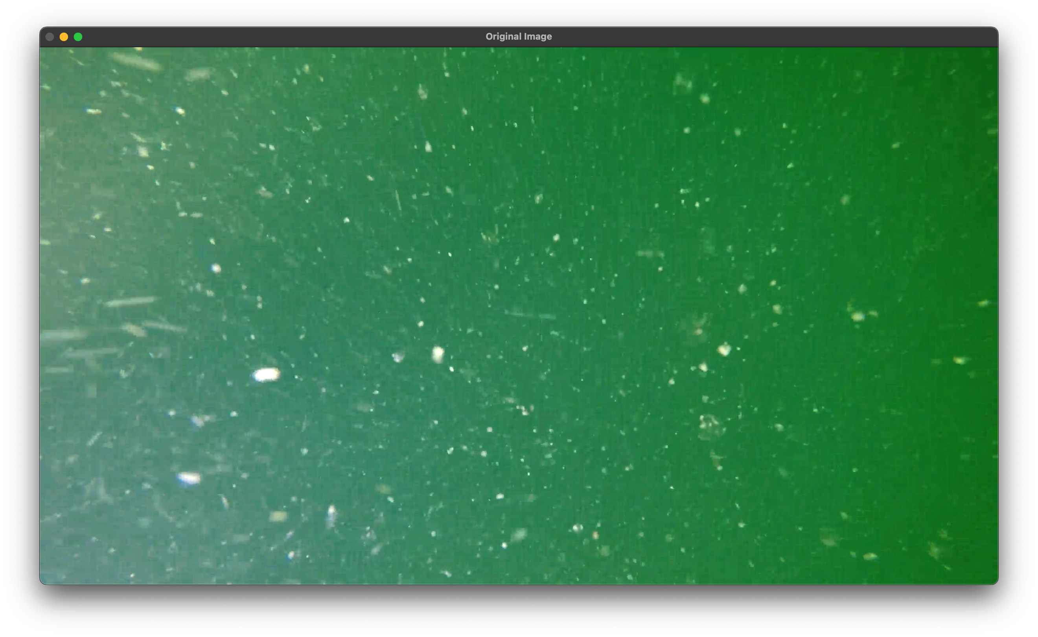

To reduce computational requirements, it’s better to convert the images into grayscale. I wanted to experiment with other types of OpenCV thresholds.

|  |
| --- |
| 1. import cv2 2. import numpy as np 3. # cv2.namedWindow("Video Stream") 4. img = cv2.imread('/Users/sid/Documents/Uni/Course/Year 4/MEng/code/frames/frame675.jpg') 5. grey = cv2.cvtColor(img, cv2.COLOR_BGR2GRAY) 6. min = 125 7. max = 255 8. thresh_value,thresh2 = cv2.threshold(grey,min,max,cv2.THRESH_BINARY_INV) 9. thresh_value,thresh3 = cv2.threshold(grey,min,max,cv2.THRESH_TRUNC) 10. thresh_value,thresh1 = cv2.threshold(grey,min,max,cv2.THRESH_BINARY) 11. thresh_value,thresh4 = cv2.threshold(grey,min,max,cv2.THRESH_TOZERO) 12. thresh_value,thresh5 = cv2.threshold(grey,min,max,cv2.THRESH_TOZERO_INV) 13. titles = ['Original Image', 'Grayscale', 'BINARY','BINARY_INV','TRUNC','TOZERO','TOZERO_INV'] 14. images = [img, grey, thresh1, thresh2, thresh3, thresh4, thresh5] 15. for i in range(6): 16. cv2.namedWindow(titles[i]) 17. cv2.imshow(titles[i], images[i]) |

The min and max variables, they define the shade of pixel to threshold, I found 125, 225 is pretty good.

|  |  |
| --- | --- |
| Grayscale |  |
| Binary |  |
| Binary_Inv |  |
| ToZero |  |
| Trunc |  |

The BinaryInv looks very promising. All backscatter particles are shown in black and there is a white background. If we had a beam splitter for the projector and camera ignoring all parallax effects, we can skip all complexities such as adding blob detection, motion prediction and simply feed the binary inv footage back to the projector.

|  |
| --- |
| 1. params = cv2.SimpleBlobDetector_Params() 2. # Since the image is binary inverse, we consider the dark areas as blobs 3. params.blobColor = 0 4. # Filter by Area. 5. params.filterByArea = True 6. params.minArea = 3 # Adjust to the approximate size of smallest blobs 7. params.filterByCircularity = False 8. params.filterByConvexity = False 9. params.filterByInertia = False 10. # Create a detector with the parameters 11. detector = cv2.SimpleBlobDetector_create(params) 12. # Detect blobs. 13. keypoints = detector.detect(thresh2) 14. # Draw detected blobs as red circles. 15. im_with_keypoints = cv2.drawKeypoints(thresh2, keypoints, np.array([]), (0, 0, 255), 16. cv2.DRAW_MATCHES_FLAGS_DRAW_RICH_KEYPOINTS) 17. cv2.imshow("Blob Detection on THRESH_BINARY_INV", im_with_keypoints) |

This is the result:

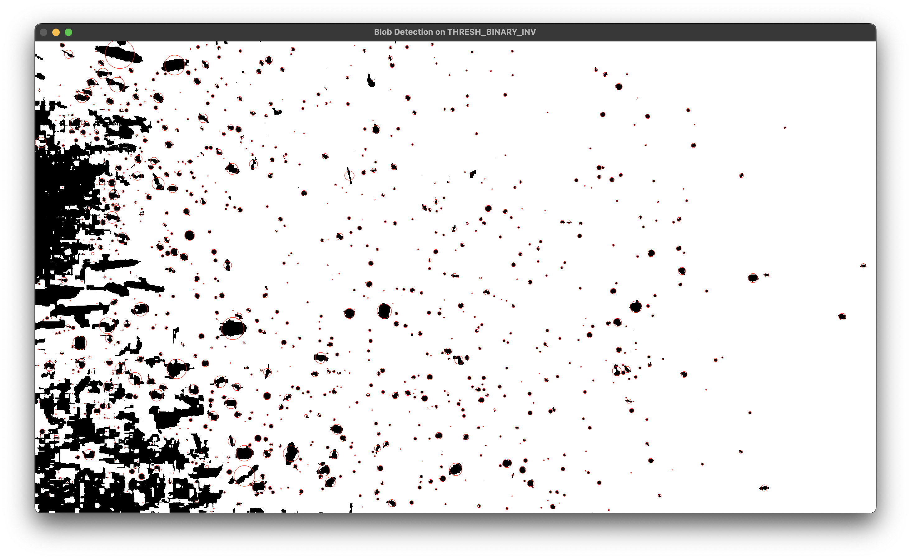

It does a decent job of detecting blob shaped blobs ☺. Where there are more abstract shapes, the detection isn’t as good.

I asked ChatGPT to generate me a picture of underwater backscatter, this is what it gave me:

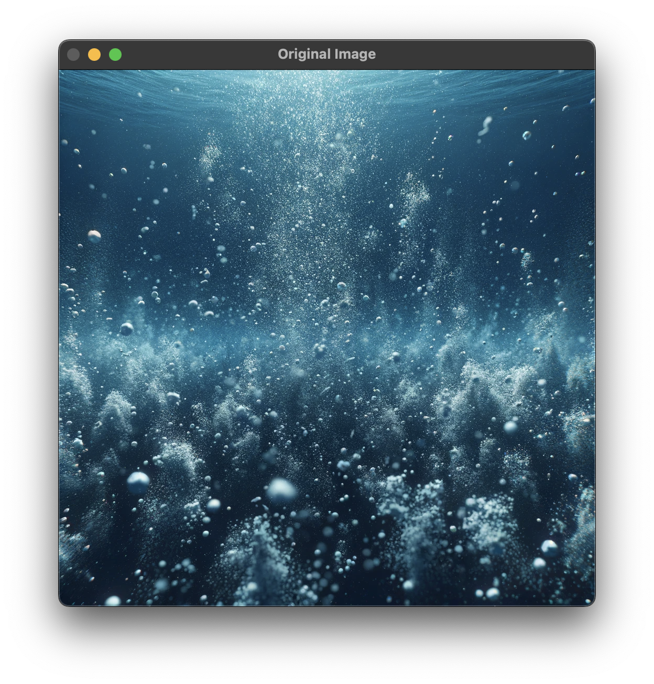

This is how the blob detection works for this image with binary inv:

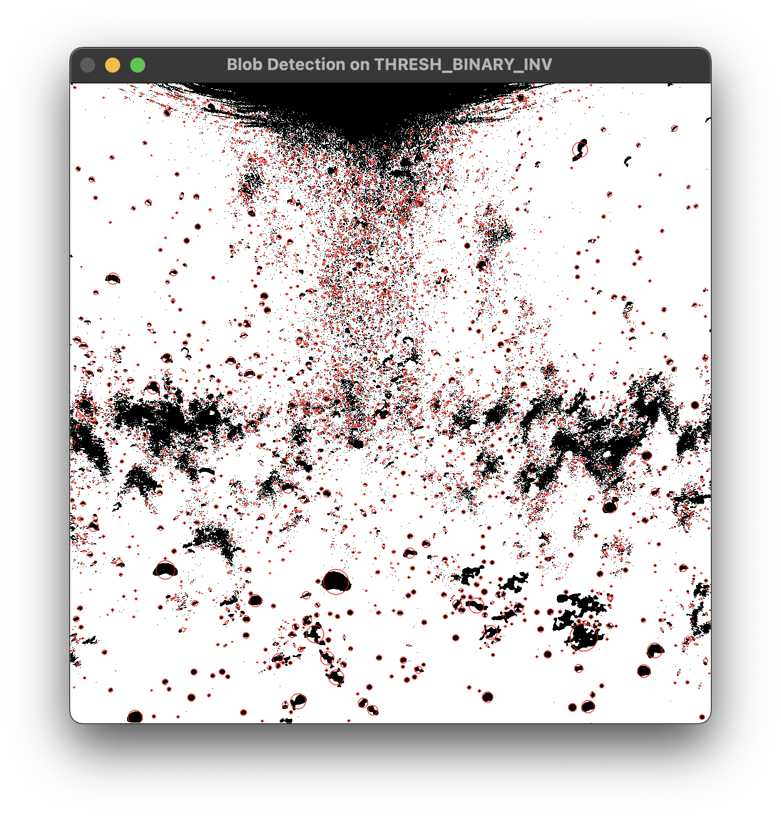

Here’s Katie’s blob detection parameters:

|  |
| --- |
| 1. params = cv2.SimpleBlobDetector_Params() 2. params.thresholdStep = 255 3. params.minRepeatability = 1 4. params.filterByColor = False 5. params.filterByArea = False 6. params.filterByCircularity = False 7. params.filterByInertia = False 8. params.filterByConvexity = False 9. # Create a detector with the parameters 10. detector = cv2.SimpleBlobDetector_create(params) 11. # Detect blobs. 12. keypoints = detector.detect(thresh2) 13. # Draw detected blobs as red circles. 14. im_with_keypoints = cv2.drawKeypoints(thresh2, keypoints, np.array([]), (0, 0, 255), 15. cv2.DRAW_MATCHES_FLAGS_DRAW_RICH_KEYPOINTS) 16. cv2.imshow("Blob Detection on THRESH_BINARY_INV", im_with_keypoints) |

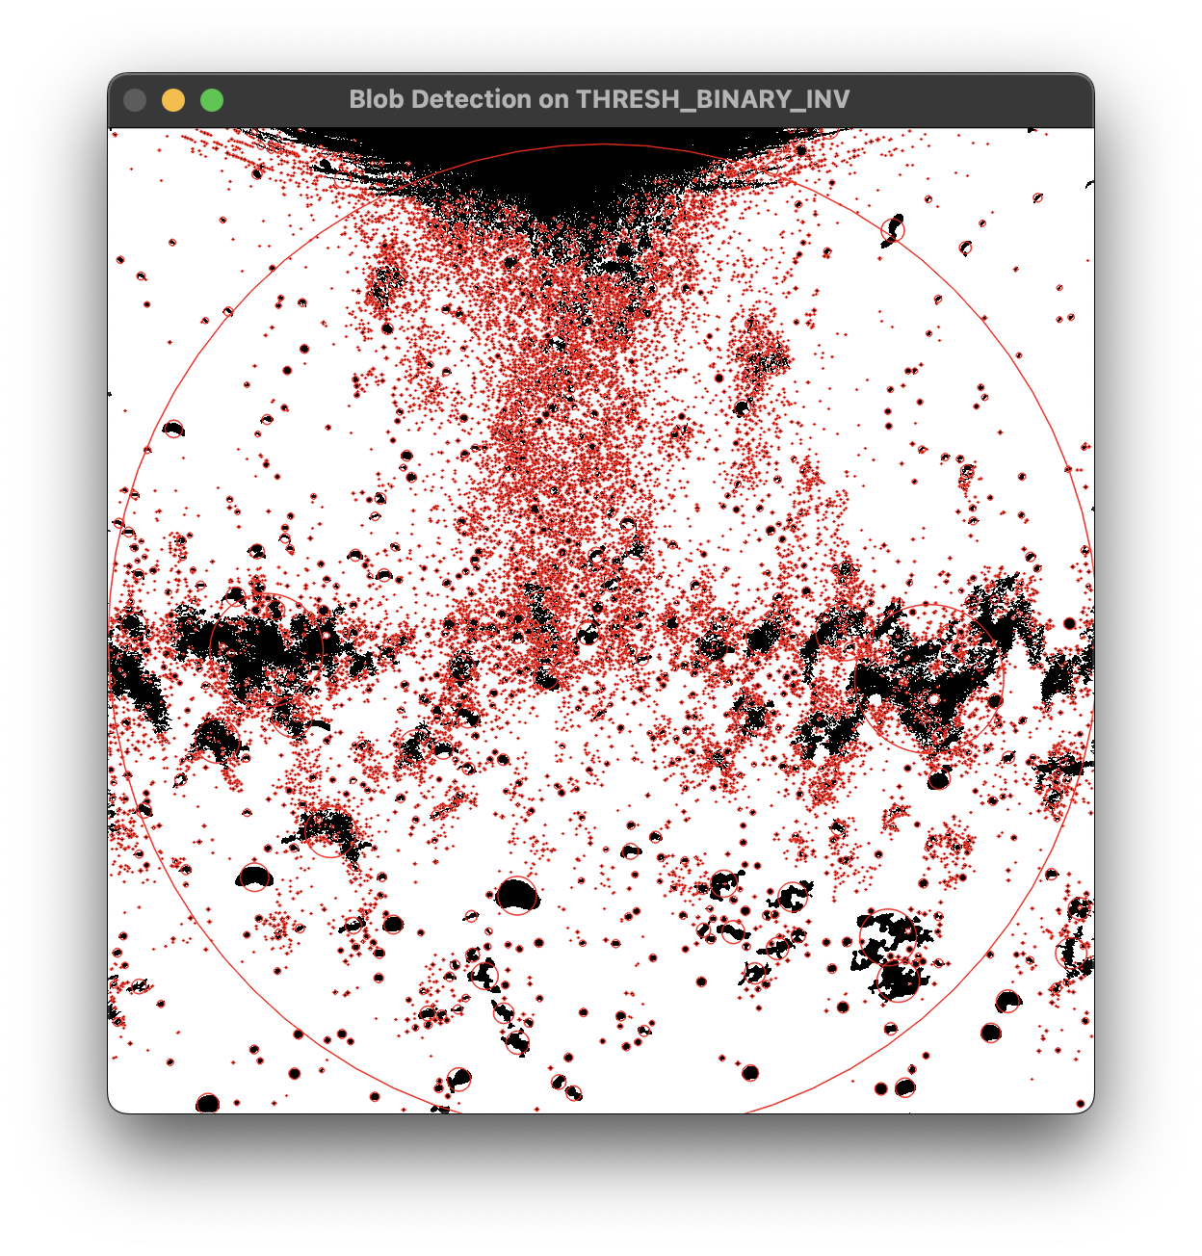

This does a better job at detecting the two black clouds on the left and right. However, it also detects the entire image and draws a circle around it. I need to understand why it’s doing this and how to fix this.

It seems quite easy and very computationally light to convert an image to binary inv and detect backscatter.

# W/B 20-11-2023

## Literature Gathering

I struggled to find some related textbooks, so I’ve turned to journals. I have currently gathered a list of papers, will be reading them, and making notes of them here. I will expand the literature collection further by exploring the cited work for each gathered paper.

## Supervision Meeting

* I gave an overview to the papers that I had gathered.
  + Some are quite specialised; it would be best to read a broader range to get more background.
  + Need to make notes on it.
  + Machine learning is very accurate and efficient, but the training is very hard.
* I showed the simple thresholding and blob detection program I was working on.
  + Work on automating the thresholding.
    - Research on histograms.
  + I can use this program as a benchmark for real-time.

# W/B 27-11-2923

## Literature Review – The Bubble Box: Towards an Automated Visual Sensor for 3D Analysis and Characterization of Marine Gas Release Sites [3]

### Introduction

This paper focusses on characterising natural and anthropogenic marine gas leaks from the ocean floor. To capture full 3D bubble shapes, this paper introduces a wide baseline stereo-camera system.

Although this paper aims to create a system to monitor and characterise greenhouse gas release sites and gas seepage in an environmental sense, many technical aspects such as bubble characterisation and tracking are shared with my project.

### Summary

Single camera (mono) based methods for bubble stream observation have become an important tool for estimating flux and bubble sizes. However, they only record a projection of a bubble into the camera and therefore can’t capture the full 3D shape, which is particularly important for larger non-spherical bubbles. This paper introduces a wide baseline stereo-camera deep-sea sensor bubble box to overcome these limitations.

The bubble box observes bubbles from two orthogonal directions using calibrated cameras. A means for appropriate camera calibration, different automated processing steps for deblurring, detection, tracking and 3D fitting are discussed since they’re crucial aspects to arrive at a 3D ellipsoidal shape and rise speed of each bubble.

The obtained values for single bubbles can be aggregated into statistical bubble size distributions or fluxes for extrapolation based on diffusion and dissolution models and large-scale acoustic surveys. The wide baseline stereo measurement model is demonstrated and evaluated using a controlled test setup with ground truth information.

### Key Concepts and Terminology

Monocular cameras are well suited for observing spherical bubbles when the distance of the bubble to the camera is exactly known.

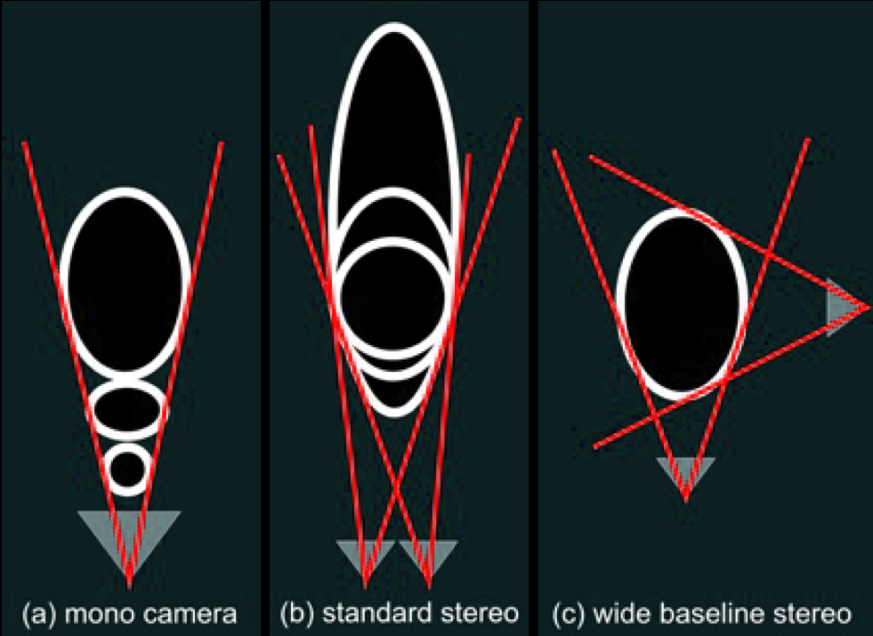

Figure 1 A visual representation showing the difference between the three types of camera systems: mono, standard stereo, and wide-baseline stereo.

The term ‘camera calibration’ stands for geometric calibration, i.e., determining which pixel corresponds to which 3D ray in water.

Region of interest is abbreviated to ROI.

Bubble flux denotes the quantity or rate at which bubbles rise or move through a particular cross-sectional area or volume within a given period. It's often measured as the number of bubbles passing through a defined area per unit time or the volume of gas carried by the bubbles through a specific area over time.

### Related Works

* Formation of seep bubble plumes in the Coal Oil Point seep field, 2010. [4]
* Optical Measurement of Bubbles: System Design and Application, 2003. [5]
* Automated gas bubble imaging at sea floor - a new method of in situ gas flux quantification, 2010. [6]
* Characteristics and scaling of bubble plumes from marine hydrocarbon seepage in the Coal Oil Point seep field, 2010. [7]
* Gas Bubble Shape Measurement and Analysis, 2014. [8]
* Two-frame Motion Estimation Based on Polynomial Expansion, 2003. [9]
* The Hungarian method for the assignment problem, 2005. [10]

### Methodology

The goal of the Bubble Box is to measure the rise speed, flux, shape, and bubble size distribution at the source position of methane or carbon dioxide seeps at the ocean floor. The system is designed to be both mobile and robust, such that it can be deployed by a remotely operated vehicle (ROV) from a research vessel.

The two GoPro Hero3 cameras that form the wide-baseline stereo system are triggered to capture using a separate micro-controller, images are then sent via a gigabit Ethernet connection to a small computer inside the pressure housing, to finally be stored in a shock resistant 1TB SSD. The system can be powered by the ROV that deploys it, or as a standalone system, it requires 60W (including lighting) during operation with negligible power during standby.

The target capture rate of the system is 120Hz, the observation corridor is approximately 20cm, which means that a bubble rising with 25cm/s in the centre of the corridor will be photographed approximately 100 times (calculation below). Faster bubbles will still be photographed, albeit at a slightly lower frequency, meaning they still can be evaluated.

$$time=\frac{distance}{speed}=\frac{20}{25}=0.8 seconds \\ number of photos=frame rate*time=120*0.8=96≈100$$

The stereo camera system is geometrically calibrated using a checkerboard image which is captured at different points of view.

Bubble detection is based on gradients within the images and will also fire on other possible structures. Therefore, it is important to have a region in both images that contain the bubble plume only. This can either be determined manually or by utilising the assumption that only moving objects in the images are the bubbles. The movement can then be detected using optical flow methods [9].

The areas of the images, where the movement is measured over time are then accumulated in a heat map and the region of interest showing the bubbles to me measured is the resulting surrounding rectangle:

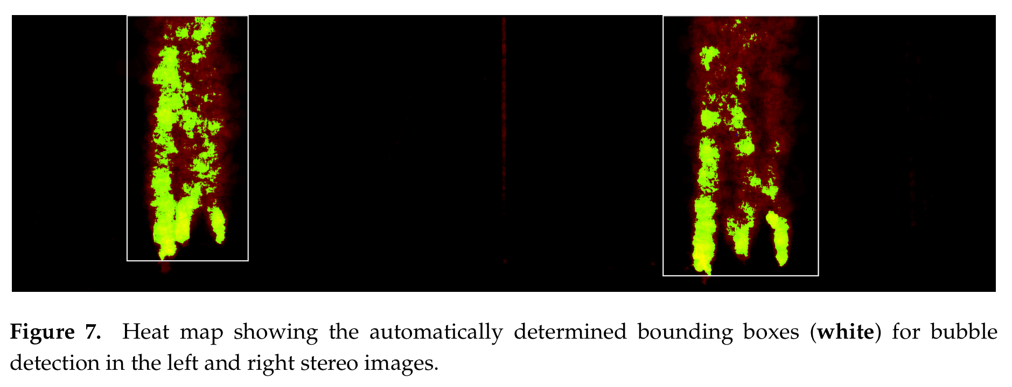

Figure 2 (Image and caption both screen-grabbed from the paper)

For successful pre-processing, the frame rates for capturing gas bubbles need to be high and exposure times need to be short in order to avoid motion blur in the images. Consequently, the capture of bubble streams requires strong illumination.

Within the region of interest in an image, the bubbles are to be detected and tracked automatically (Refer to [8] for a more detailed description of the bubble detector and tracker). For this, images are interpreted as a function mapping a grey value to each pixel. In this function, gradients can be computed and used for line-detection with the Canny edge-detector as in [6]. The edges are then used to determine the bubble contours by tracing the convex hull of the connected components. Extra contours inside the bubbles are rejected by checking for overlapping detections:

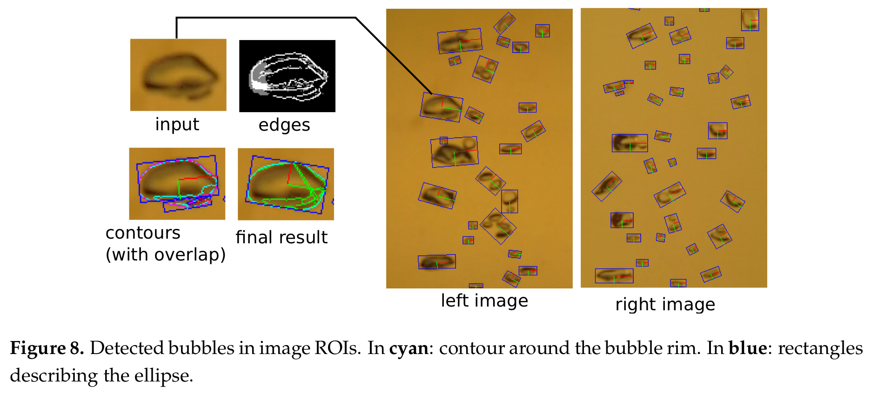

Figure 3 (Image and caption both screen-grabbed from the paper)

Bubbles are tracked over the image sequence, i.e., over time. Since they usually following a constant upwards motion with certain deviations to the left and right, it is possible to specify an upwards and a sideways motion constraint, this allowing the determination of a set of possible matching candidates between two consecutive images. The matching candidates are assigned a weighting factor based on the motion constraint, which leads to a minimum-weighted, bipartite matching problem, which is a classical graph problem and can be solved by the Hungarian algorithm [10]. When combining the correspondences over time, the entire trajectory of the individual bubbles can be inferred.

### Findings

A method to detect bubbles has been found – Canny edge detection is used. This may work better than using blob detection:

Simple Blob Detection is better suited for spherical or near-spherical objects, Canny would be more versatile in detecting bubbles of varying shapes and sizes. Canny would work great in situations where the edges of the bubbles are well defined and consistent – thresholding methods may need to be compared with Canny.

Canny is much more sensitive to noise in the image, this could lead to false positives or negatives or incorrect edges, whereas simple blob detection can be more robust against this.

If there's significant clutter or complex background in the images, Canny might provide cleaner edges of bubbles compared to blob detection. Canny tends to be computationally more intensive compared to Simple Blob Detection.

### Discussion and Conclusion

Although this paper is related to a completely different field, it contains many image processing and machine vision fundamentals. Many of these fundamental aspects weren’t discussed in-depth, however, literature that do delve into the technicalities have been referenced.

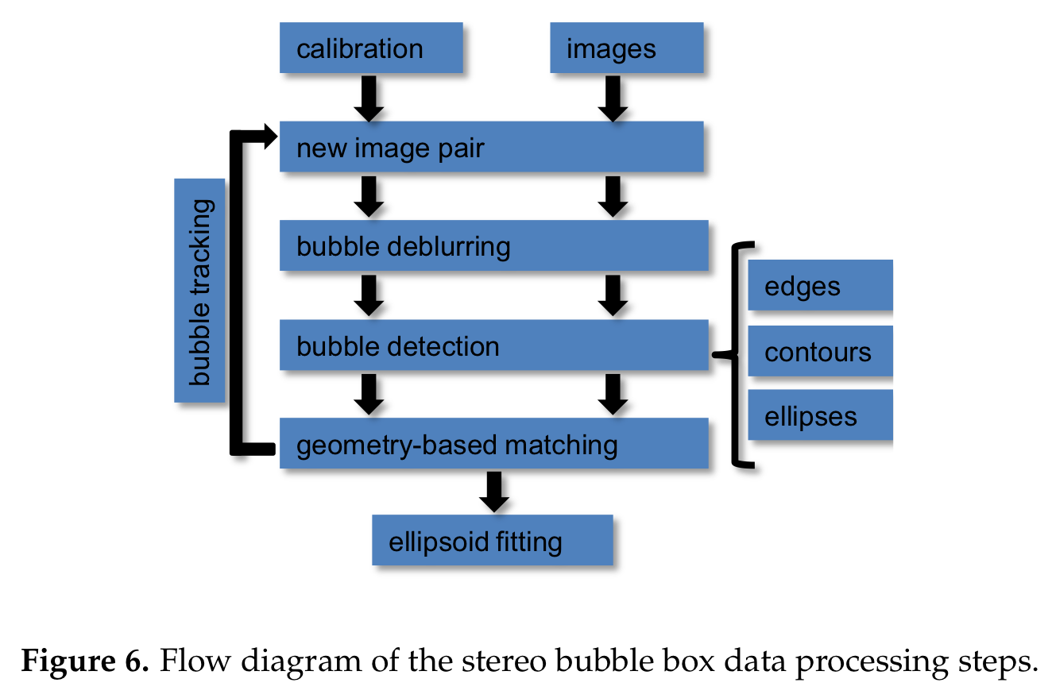

Figure 4 (Image and caption both screen-grabbed from the paper)

The paper gave a detailed overview of the processes that are required detect and track bubbles to characterise gas seepage for environmental insight. The system that captures the image frames for the bubble processing is placed on the seabed, with the bubbles travelling vertically upwards. This forms a very large incompatibility issue with my project, since the UUV will be capturing frames of the seabed, not from the seabed. Luckily, the processes can be duplicated, albeit with slight modifications to account for the difference in perspective.

## Literature Review – Gas Bubble Shape Measurement and Analysis [8]

### Introduction

This paper focusses on the precise quantification of bubble streams from underwater gas seeps. The performance of the snake-based method and of ellipse filling with the CMA-ES non-linear optimisation algorithm is evaluated. The paper also presents an improved snake-based method, with the optimal snake parameters studied. A Kalman filter is used for bubble tracking.

This paper has a very large overlap with my project despite being targeted for quantification of gas seeps. Technical aspects such as bubble detection and tracking can be duplicated, and of course, expanded to integrate with all forms of backscatter such as various marine debris.

### Summary

Gas bubbles emerging from a seep in the sea floor are rising with high speed, and my change form, contour, and volume during their ascent. The goal of this research is the development of robust methods for automatic image processing, which can be employed to extract the shape, motion, and volume of bubbles from image sequences.

The first part of this paper is dedicated to the detection of gas bubbles. Several methods are compared, the snake approach [11] and ellipse filling with the CMA-ES non-linear optimisation algorithm [12]. Other detection methods are established in other work: In [13] active contours are initialised using the boundaries of the binarized input image. In [6], the application of a Canny edge detector for contour extraction is presented. The detected contours are fitted and smoothed with an ellipse. In this paper, the Canny edge detection method from [6] is used as a baseline.

The second part of this paper is dedicated to the tracking of bubbles and the measuring of their velocity. The accuracy of the detection and tracking methods in combination are verified by the comparison with annually obtained flux data.

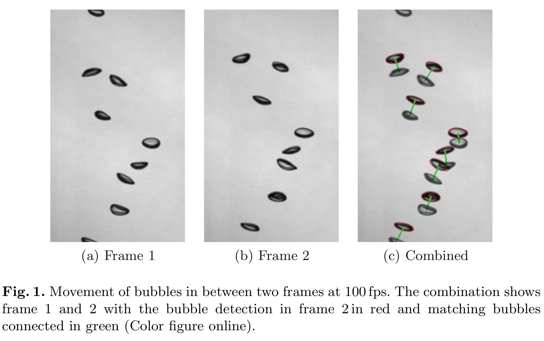

Figure 5 (Image and caption both screen-grabbed from the paper)

### Key Concepts and Terminology

A snake [in the snake method] is an energy-minimizing spline guided by external constraint forces and influenced by image forces that pull it toward features such as lines and edges. Snakes are active contour models: they lock onto nearby edges, localizing them accurately [11].

The CMA-ES (Covariance Matrix Adaptation – Evolution Strategy) is an optimisation algorithm used to solve non-linear, non-convex optimisation problems. It belongs to the family of evolutionary algorithms and is particularly effective for continuous optimisation tasks where the objective function may be multimodal, noisy, or complex.

### Related Works

* The Hungarian method for the assignment problem, 2005. [10]
* Snakes: Active contour models, 1988. [11]
* Evaluating the CMA Evolution Strategy on Multimodal Test Functions, 2004. [12]
* Bubble Recognition From Image Sequences, 2001. [13]
* Automated gas bubble imaging at sea floor – a new method of in situ gas flux quantification, 2010. [6]

### Methodology

Methods for the reliable detection of bubble contour in image sequences are developed with the Canny edge detector method used as a baseline. The Canny edge detector sporadically suffers from false detections due to the light area inside the bubble, hence motivating the search for more stable algorithms. As an improvement, a bounding box is formed around the Canny detections and expanded. This bounding box is used as an initialisation for the snake and CMA-ES-based methods.

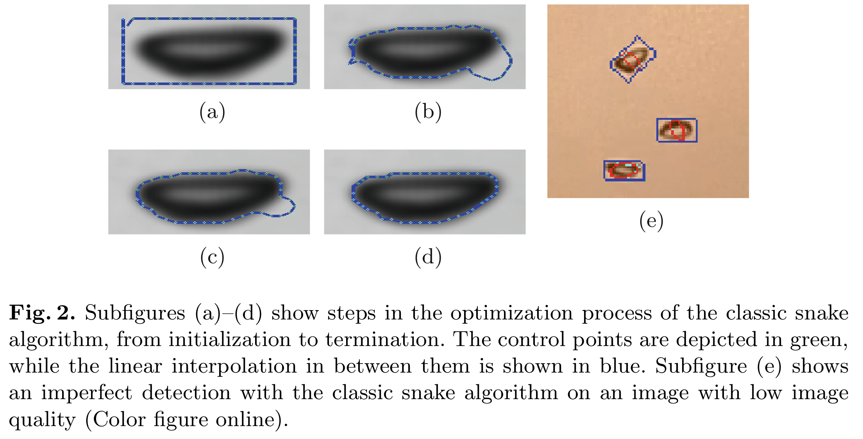

Figure 6 (Image and caption both screen-grabbed from the paper)

The snake term describes a spline which is adjusted by the snake method to fit a prior defined criterion. For every contour, an energy function is declared. The figure above shows different iterations of a successful localisation of a bubble with a snake from initialisation to convergence. Above in (e) shows an example of the classic snake approach not working reliably due to light inside the bubble. Therefore, an improved snake method is proposed:

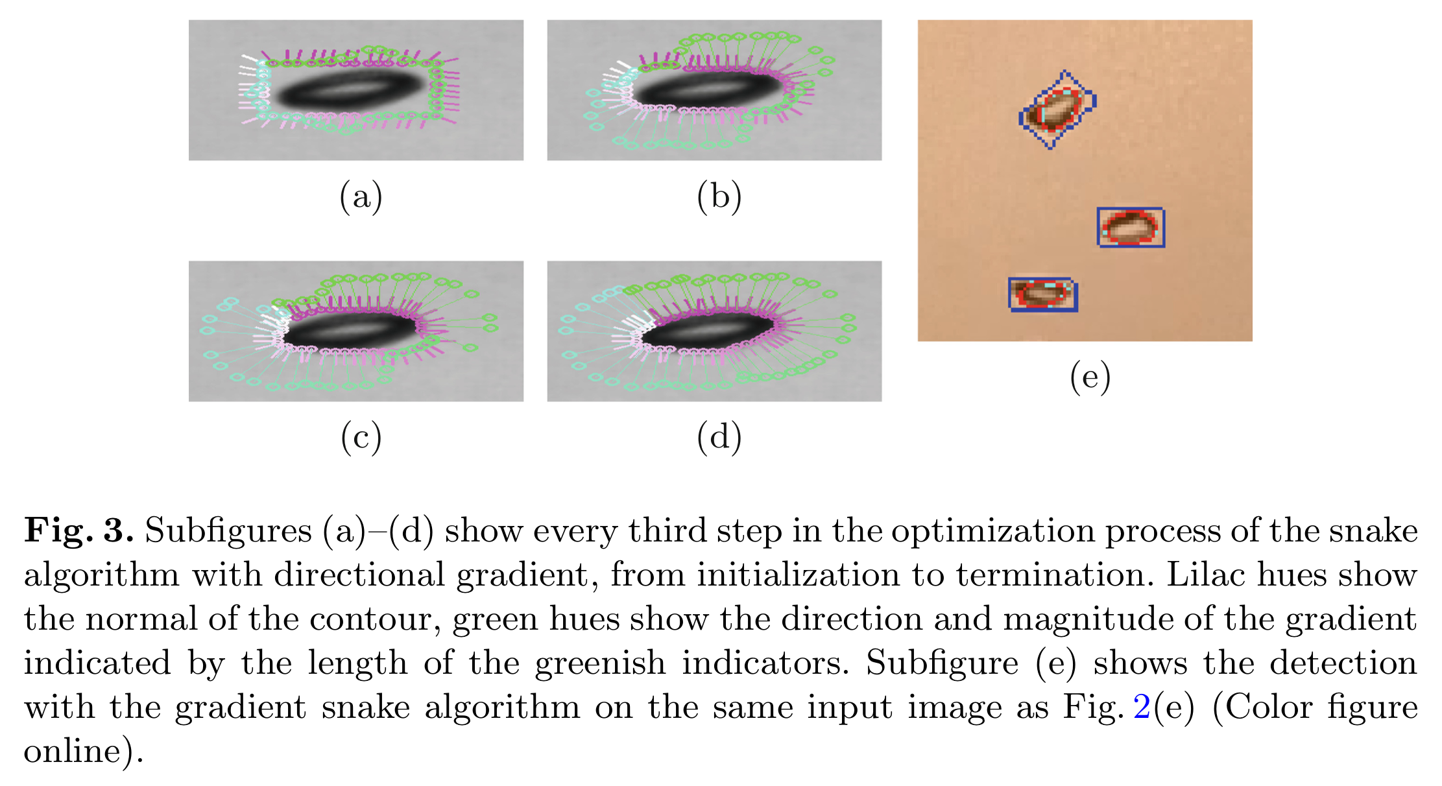

Figure 7 (Image and caption both screen-grabbed from the paper)

Covariance Matric Adaption – Evolution Strategy (CMA-ES) is a derivative free non-linear optimisation algorithm. For the detection of gas bubbles, the algorithm is initialised with the expanded bounding box of the Canny edge detection, as described above. The CMA-ES algorithm then adjusts an ellipse to the bubble, according to a prior defined fitness function.

The ellipse used in the optimisation is defined by five parameters: the horizontal and vertical position of the bubble, its minor and major axis, and a rotation parameter. Different fitness functions have been developed and tested. Two designs showed the best results, firstly a fitness function aiming for a high gradient on the edge of the ellipse and secondly an area-based fitness function evaluating the difference between the mean intensities of the ellipse area and its surroundings.

Tracking is employed to determine the movement of bubbles in-between two frames and from this data, over the entire image sequence. To effectively find the corresponding bubble detections between two frames, the bubble positions are detected in every frame. The motion since the last frame is predicted using a Kalman filter.

These predictions and the new detections of bubble positions are matched with minimum weighted matching between prediction and measurement using the Hungarian algorithm [10], with the distances between these as edge weights. This resulting matching is the mapping of bubble movement between the last frame and this frame. A resulting matching is shown in Figure 5, on the right image.

### Findings

The different bubble detection methods were compared with manual ground truth for an image sequence of 20 images with ~10 bubbles per visible frame. All tested methods show good results and a clear improvement compared to the baseline Canny edge detector, however, both snake-based methods showed the best performance.

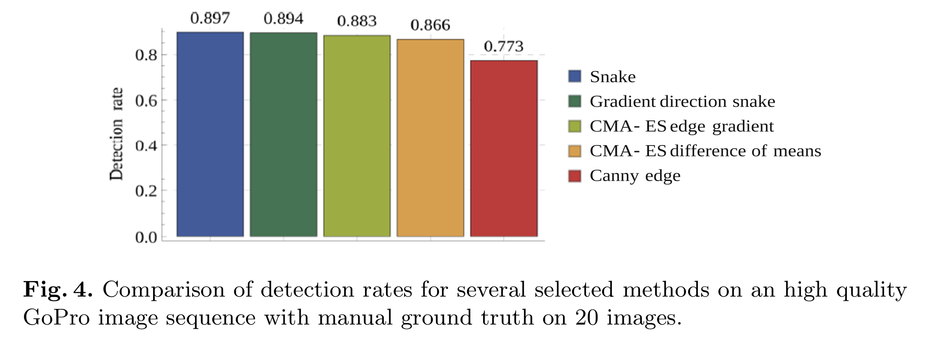

Figure 8 (Image and caption both screen-grabbed from the paper)

The fastest method is the classic snake algorithm with timings of about 30ms per frame. The gradient snake has been determined as the bubble detection method of choice, despite being slower, since it’s the most reliable on images with low quality.

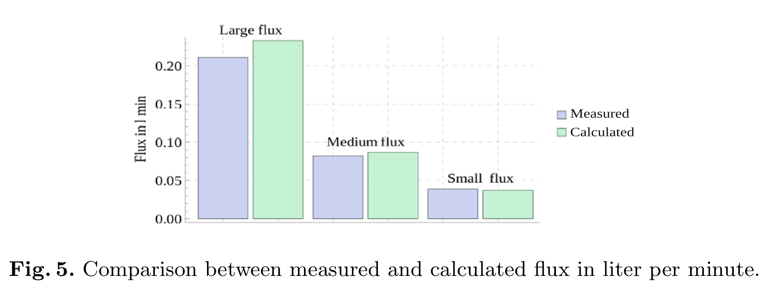

Figure 9 (Image and caption both screen-grabbed from the paper)

For bubble tracking, in the tested 20 sequences, with a bubble detection rate according to Figure 9, the tracking is highly reliable. For a sequence such as Figure 5, the framerate can be lowered by 50% without deteriorating the tracking quality.

### Discussion and Conclusion

This paper outlines methods for both detecting and tracking bubbles. The Canny method for bubble detection is taken as a benchmark and starting point, with more advanced algorithms to fine-tune the detected region to wrap around the shape of the bubble. This forms a great way to dynamically calculate the exact dimensions for the ‘hole’ when it comes to eliminating marine backscatter with a DLP projector.

Bubble tracking is done by looking at two consecutive frames and applying the Kalman filter. I need to do some more reading on Kalman filters, however, judging by the quantified results outlined in this paper, the performance is extremely good. This method can be invaluable when it comes to predicting the future position of marine backscatter to eliminate, potentially drastically reducing the computational overhead that is required in the backscatter detection logic.

The paper also mentions the CMA-ES method for bubble detection with ellipse fitting. Not much depth is covered, and it seems like quite a difficult technique to understand. Luckily, the paper does state that it doesn’t perform as well as the classic snake and gradient snake, so I may not need to read into this too much.

# W/B 04-12-2023

## Supervision meeting

* Discussed research findings.
  + It’s good to start with fundamental practices such as simple blob detection, Canny, etc.
  + With a solid fundamental understanding, I can explore AI/ML avenues to employ a neural network to improve the parameters to detect bubbles and predict movement.
  + Both papers that I’ve read cites [6] to provide more technical aspects on how Canny is set up to work, I need to read this for a better understanding.
  + The conference paper that I read shows the methodology and results, but not the code/algorithm parameters – I was suggested to search the authors to find the associated journal paper since that may go into more depth. Title may be different.
* Discussed hypervisor aspects.
  + Hypervisor is a solution to run programs at the lowest-level closest to system functions (must have high priority level to reduce task switching that causes jitter).
  + Compare the differences between Jailhouse and Docker.
* Discussed real-time aspects.
  + Starting in Python, I could use implement various tasks in the form of functions, one for capturing a frame, one for processing the frame, one for Canny, one for tracking prediction, etc, for example.
  + With these tasks in functions, I can use the thread package *(maybe)* to implement a simple round-robin task scheduler.
  + I can log the entry and exit times for each task to measure how long it takes to parameterise real-time.
  + Based on these parameters I can fine-tune the algorithm parameters to make it conform to real-time requirements.
  + An idea that I thought of on the way home after the meeting:
    - I can set up a *(sort of)* SysTick handler in Python [14]:

1. import threading
2. def hello():
3. print('Hello')
4. a=1
6. t = threading.Timer(5.0, hello)
7. t.start()
8. a=0
9. while(a==0):
10. print("you're here")
11. print('Good By')
    * + By setting the threading timer, I can control the time for each tick, I can then use the tick counter to measure the time it takes for a task – measure ticks when entering the task, and when exiting the task.
      + Perhaps, with the Pi 5, I can set up an external timer with the build in real-time clock?
      + Further to this, at every tick, I can force the round-robin task scheduler to switch to the next task.
      + This way I can force a specific timing constraint requirement for real-time, at the expense of some jitter.
      + But do I really need to force switch to the other task, given the nature of this project?
        - For example, if a task is to pre-process a frame, then the next is to run Canny, if the pre-process task is force switched then Canny cannot run.
      + Software interrupts can be written using a GPIO pin as a trigger, perfect for a real-time clock or the global shutter interrupt [15]

* Ordering components.
  + The list of components I proposed was good, we should add the global shutter camera to the list.

# W/B 22-01-2023

## Working with real-time constraints: Docker vs Jailhouse

Jailhouse is a simple partitioning hypervisor that allows creating partitions on a multicore system where each partition runs its own operating system, with each partition isolated from each other to ensure safety. Docker, on the other hand, is a containerisation platform that allows the packaging and distribution of applications in a consistent and reproductible method, with containers sharing the host OS resources and portable to ensure consistent execution across different environments. While both Jailhouse and Docker can provide means to dedicate hardware resources such as CPU cores, RAM, etc, they do not prioritise or manage the execution priority of task within a single partition or container.

A RTOS ensures the best possible chance of meeting real-time constraints. FreeRTOS is a popular and open-source real-time operating system for microcontrollers, although there is kernel support for the Pi Pico, the Pi 4 is not supported. Since there is no FreeRTOS support for our Pi 4, we can explore methods to modify the Ubuntu Server OS Linux kernel to implement real-time functionalities. PREEMPT_RT is a patch set for the Linux kernel that introduces full pre-emption and real-time capabilities. The website in [16] guides through the steps to implement the PREEMPT_RT patch to the default Ubuntu 22.04 LTS Desktop OS kernel.

Altering the priority level of the Python script is possible at the script’s runtime using the chrt command or the nice command (both run as sudo). Altering the priority level is also possible from within the Python script using the os.nice() function. When running the Python script, we can monitor the jitter caused by OS prioritisation of other tasks visually, backed up with the top command output. If there is a lot of jitter and there are other tasks with higher priority that are consuming more of the CPU’s time, we can look into (a) closing and disabling the higher priority task causing the jitter in our code, (b) uninstall the jitter causing higher priority task, or (c) increase the priority level of the Python script to ensure better prioritisation.

**Gauge effectiveness of the RT kernel by benchmarking and comparing:** Write a Python script with OpenCV reading a video feed and apply some processing to each frame, perhaps implement the simple blob detection logic for the bubble detection from earlier. Compute the time it takes to process each frame. Run this Python script on both the standard kernel and the RT kernel to plot the differences in performances. Keep the priority level setting constant between both environments to see if there are any differences.

## Preparing Pi for remote connections within the university network

Due to security issues, it is not possible to connect the Raspberry Pi to the Eduroam university network, also noted in Katie’s paper in Appendix A.1. This incurs a major roadblock preventing the remote communications to the Pi via SSH and communications to the internet from the Pi. Considering two aspects for complete connectivity: (a) seamless SSH connection from laptop to Pi, (b) seamless internet connection from Pi to the internet.

To ensure seamless connectivity from my laptop to the Pi, I connected the Pi to my laptop via Ethernet. Unfortunately, this step was not sufficient to access the Pi via SSH as the Pi was somehow unreachable from my laptop using the hostname I manually set for the Pi. I had to add the following line [17] to the end of cmdline.txt, accessible by plugging in the Pi’s SD card into my laptop and browsing in the boot partition.

1. ip=192.168.0.5::192.168.0.1:255.255.255.0:rpi

The line above sets the Pi to have a static IP address of 192.168.0.5, the gateway is set to 192.168.0.1 (this will be the IP of the laptop), the netmask is 255.255.255.0. Plug in the SD card into the Pi, power it up and connect to the laptop via Ethernet. In macOS System Settings, there should be a new Ethernet listing in the Networks page:

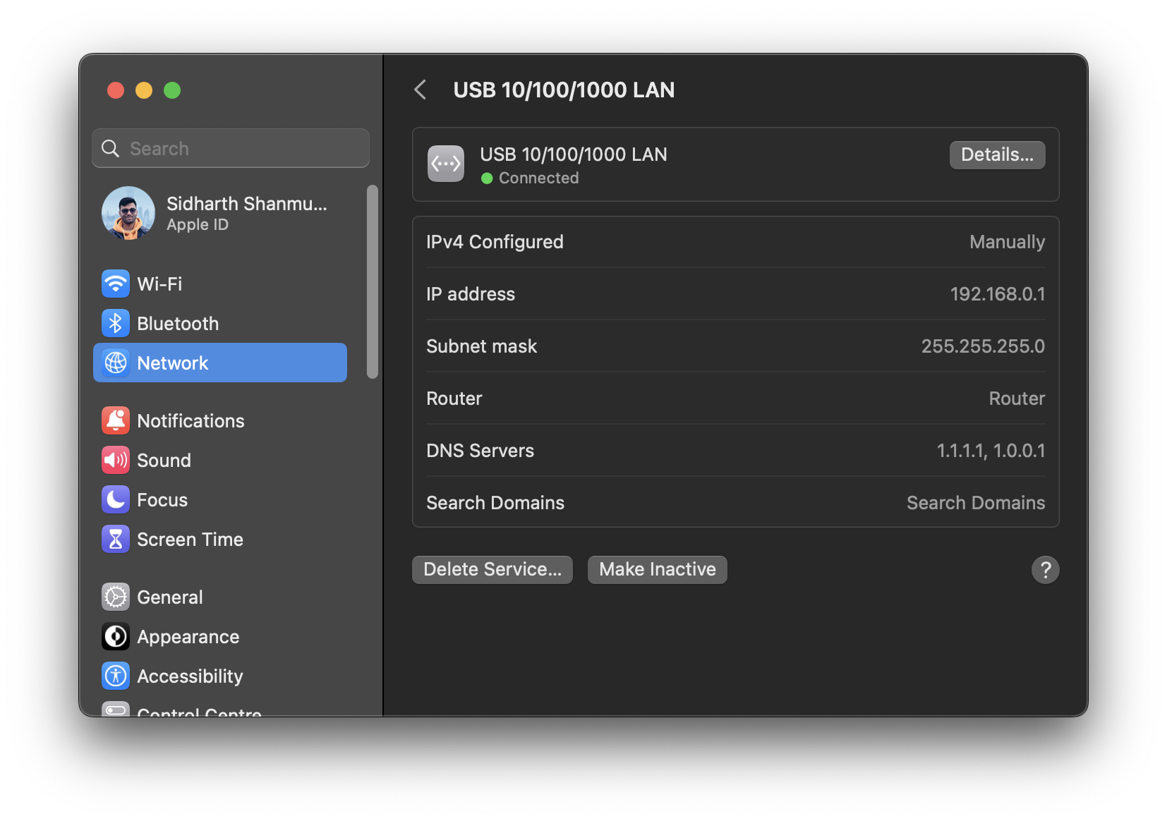

The addresses need manual overriding, without any DHCP. Set the IP and subnet mask to the address and mask that was mentioned for the gateway in the above cmdline.txt snippet. It will not be possible to log into the Pi via SSH from the laptop using the manually set hostname (sidmeng.local) or the static IP address set with the cmdline.txt snippet.

To access the internet, since it is not possible to connect to Eduroam we need to look for alternatives. Katie used the CityConnectWifi, which is a network provided by City of York Council. This is not very secure, so I will be connecting to the University’s mydevices network. This network is mainly used for games consoles, smart home devices, etc. The mac address of the Pi must be registered via the registration page. Mac address of the wlan0 interface is accessible from running the ‘ip a’ command.

First update the Netplan configurations to add the new Wi-Fi connection, access config file with ‘sudo nano /etc/netplan/50-cloud-init.yaml’:

1. network:
2. version: 2
3. wifis:
4. renderer: networkd
5. wlan0:
6. access-points:
7. 1Escrick:
8. password: secretpass
9. mydevices:
10. password: connectme
11. dhcp4: true
12. optional: true
13. ethernets:
14. eth0:
15. dhcp4: false

Now after applying the new config using ‘sudo netplan apply’ the internet will still not be accessible, as confirmed by running ‘ping google.com’. This is due to the eth0 interface (connection to laptop for SSH and no internet sharing) becoming the default IP route, which is a path that network traffic takes from one computer to another on a network. The laptop is not set up for internet sharing due to issues that I faced trying to get SSH to work. This can be confirmed by running ‘ip route show’:

1. sid@sidmeng:~$ ip route show
2. default via 192.168.0.1 dev eth0 proto static
3. default via 10.241.96.1 dev wlan0 proto dhcp src 10.241.99.77 metric 600
4. 10.241.96.0/22 dev wlan0 proto kernel scope link src 10.241.99.77 metric 600
5. 10.241.96.1 dev wlan0 proto dhcp scope link src 10.241.99.77 metric 600
6. 144.32.128.7 via 10.241.96.1 dev wlan0 proto dhcp src 10.241.99.77 metric 600
7. 144.32.128.17 via 10.241.96.1 dev wlan0 proto dhcp src 10.241.99.77 metric 600
8. 144.32.128.27 via 10.241.96.1 dev wlan0 proto dhcp src 10.241.99.77 metric 600
9. 144.32.128.242 via 10.241.96.1 dev wlan0 proto dhcp src 10.241.99.77 metric 600
10. 144.32.128.243 via 10.241.96.1 dev wlan0 proto dhcp src 10.241.99.77 metric 600
11. 144.32.129.82 via 10.241.96.1 dev wlan0 proto dhcp src 10.241.99.77 metric 600
12. 192.168.0.0/24 dev eth0 proto kernel scope link src 192.168.0.5

The first line of the output shows the default route via 192.168.0.1 (which is the IP of the laptop). Instead of this, the second line should ideally be the default route. This can be resolved using the command ‘sudo ip route del default via 192.168.0.1 dev eth0’, however, this command will need to run every time the Pi reboots. Crontab helps automating this command to run at every reboot. Run ‘sudo crontab -e’ to access the Crontab, at the end add the following line:

1. @reboot sudo ip route del default via 192.168.0.1 dev eth0

Now after a reboot the internet becomes accessible, confirmed by running a ping. Since the Pi is running Ubuntu Server OS, there is no pre-installed desktop environment. The absence of a desktop environment reduces the storage consumption of the overall system and preserves much of the computational resources. It is possible to output a video directly a HDMI-connected peripheral such as a projector by outputting to the framebuffer. For development purposes, it is possible initialise a remote graphical display on the machine used to SSH into the Pi. The XQuartz X window server can be installed on Mac (with Homebrew) with:

1. brew install --cask xquartz

After restarting the Mac, we can SSH into the Pi with a flag to enable X11 forwarding:

1. ssh -X [sid@sidmeng.local](mailto:sid@sidmeng.local)

Now, after logging in, you can launch an app/script that uses GUI windows and XQuartz will render them via SSH on the Mac.

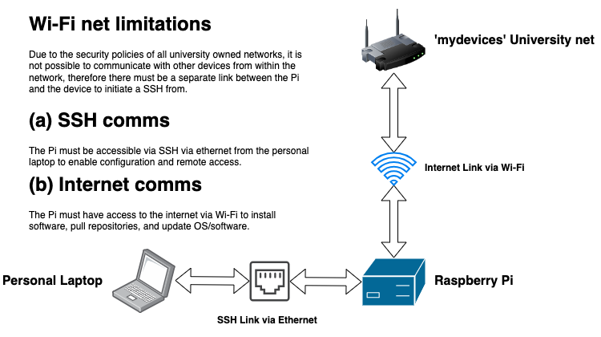

## Literature Review – Automated gas bubble imaging at sea floor – a new method of in situ gas flux quantification [6]

### Introduction

This paper presents the design of a novel method for automated gas bubble imaging at the sea floor, its validation procedures and calibration experiments. The main aim is to quantify gas flux from gas release sites on the sea floor for environmental analysis. There are many sections on the construction of the system and quantifying gas flux measurements, however, the sections of most interest are “2.2 Image processing and analysis” for details on Canny-powered bubble detection, and “3.2 Bubble assignment” for details on bubble tracking using the least distance assumption.

### Summary of Methodology

In the section “2.2 Image processing and analysis”, the paper explores an automated routine for processing and analysing images with statistically relevant numbers of gas bubbles within reasonable time and accuracy. The paper lists the need for an algorithm to perform simple and fast segmentation as well as feature extraction with the capability of tracking individual bubbles and storing the results in a useful format. The authors have abstracted the system into two key factors, (a) isolating the bubbles from the background, and (b) determining their position and sizes. The authors also mention that the second factor can track bubbles in successive frames, analyse and store the data in a cubic matrix. I’m not entirely sure what they mean by a ‘cubic matrix’ in this context, but I assume it is relevant to environmental analysis and can be safely ignored.

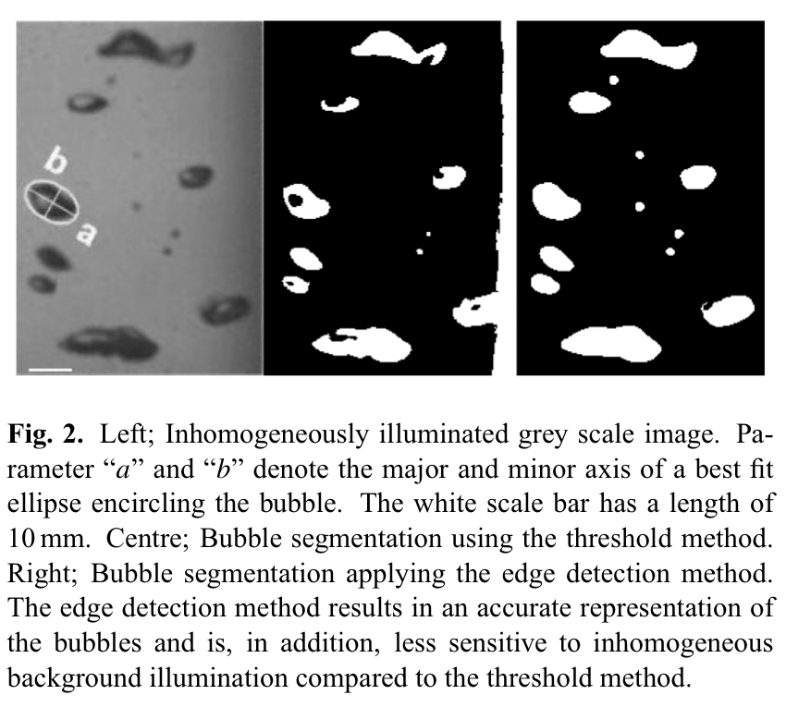

Figure 10 (Image and caption both screen-grabbed from the paper)

Segmentation is the process of discriminating objects of interest from the remaining frame. In this case, it is the process of deciding whether any image pixel belongs to a bubble or is part of the background. In the segmentation process described in this paper, the “Canny” [18] filter is used for a grey value images, it compares the value of each pixel relative to the values of its neighbours. When the grey value gradient between two adjacent pixels is larger than a certain threshold, the pixel is set to a value of binary ‘1’, otherwise ‘0’. As a result, edges are created around objects. Figure 10 from the paper outlines the advantages of employing an edge detection strategy rather than applying a simple grey value threshold (thresholding). The edge detection approach identifies bubble boundaries accurately even in inhomogeneously illuminated areas, therefore can be applied to images with steadily decreasing light intensities. However, two disadvantages to Canny are present – the first, computing time will drastically increase when compared to a simple thresholding approach, the second is that bubbles can grow or shrink during segmentation, although morphological techniques such as dilation and erosion can tackle this issue, it adds additional computational overheads. In general, feature extraction is the process of reducing the object information to the relevant key features of interest. Shown in Figure 10, the bubble size as well as the centre of the bubble area is determined using the MATLAB routing “Region-props”, these values are based on an elliptical best fit.

With the realisation of the assumption that the distance a bubble has travelled in two successive frames is smaller than the distance to its closest neighbour, tracking of bubbles in successive frames with the computation of rise velocity is possible. This assumption is valid except for overlapping bubbles, very high bubble concentrations, and for low acquisition frequencies, where travel distance is greater than neighbourhood bubble distance. Objects that do not move or sink are automatically excluded.

### Discussion and Conclusion

This paper outlines methods for both detection and tracking bubbles, employing the Canny edge detection algorithm for detection, and the ‘least distance’ assumption for tracking. When comparing to the employed methodologies in [8], this paper discusses the more fundamental tools, such as Canny without any optimisation such as the snake method, and without a Kalman filter for bubble tracking. Therefore, a solution employing the methods in this paper can form a great benchmark which can form comparisons with more advanced algorithms to fine-tune the results, though at the expense of computation time and complexity.

## Component Ordering List

|  |  |  |  |  |  |
| --- | --- | --- | --- | --- | --- |
| Item | Supplier | Item Price (exc. VAT/ £) | Shipping Price (exc. VAT/ £) | Total Price (exc. VAT/ £) | Total Price (inc. VAT/ £) |
| [RASPBERRY-PI RPI5-8GB-SINGLE](https://uk.farnell.com/raspberry-pi/rpi5-8gb-single/raspberry-pi-5-model-b-8gb-2-4ghz/dp/4256000?ICID=I-RP-STM7REC-0) | Farnell | 66.12 | 0.00 | 66.12 | 79.34 |
| [27W, 5.1V, 5A Raspberry Pi 5 Power Supply, UK White - SC1149](https://cpc.farnell.com/raspberry-pi/sc1149/rpi-5-27w-usb-c-psu-uk-white/dp/SC20194?st=raspberry%20pi%2027w) | CPC Farnell | 9.92 | 0.00 | 9.92 | 11.91 |
| [Raspberry Pi Accessories Raspberry Pi 5 Case Red/White](https://www.mouser.co.uk/ProductDetail/Raspberry-Pi/SC1159?qs=HoCaDK9Nz5d9gZHizvivRA%3D%3D&src=raspberrypi) | Mouser | 8.00 | 0.00 | 8.00 | 9.60 |
| [RASPBERRY-PI SC0926 Global Shutter Camera](https://uk.farnell.com/raspberry-pi/sc0926/global-shutter-camera-computer/dp/4163984?ost=raspberry+pi+global+shutter&cfm=true) | Farnell | 41.33 | 0.00 | 41.33 | 49.60 |
| [HDMI Cables 789RP-19040301W Micro-HDMI/M to HDMI-A/M Cable, 1M, White SONY:UCON00977](https://www.mouser.co.uk/ProductDetail/Raspberry-Pi/SC0358?qs=T%252BzbugeAwjhj7g4NyENHBA%3D%3D) | Mouser | 4.00 | 0.00 | 4.00 | 4.8 |
| [Lexar JUMPDRIVE S47 64GB USB 3.1 Black LJDS47-64GABBK](https://www.amazon.co.uk/Lexar-JUMPDRIVE-S47-64GB-Black/dp/B07XNXR549/) | Amazon | 9.99 | 0.00 | 9.99 | 11.99 |
|  | | | | **139.36** | **167.24** |

# References

|  |  |
| --- | --- |
| [1] | S. Doran, “How to Perform Real-Time Processing on the Raspberry Pi - SCALE 13X,” 19 June 2015. [Online]. Available: https://www.socallinuxexpo.org/sites/default/files/presentations/Steven_Doran_SCALE_13x.pdf. [Accessed 6 11 2023]. |
| [2] | kbarni, “OpenCV Forum,” 25 June 2021. [Online]. Available: https://forum.opencv.org/t/python-vs-c-personal-experiences-with-using-both/4016/2. [Accessed 14 November 2023]. |
| [3] | A. Jordt, C. Zelenka, J. S. v. Deimling, R. Koch and K. Köser, “The Bubble Box: Towards an Automated Visual Sensor for 3D Analysis and Characterization of Marine Gas Release Sites,” *Sensors,* vol. 15, no. 12, p. 30716–30735, 2015. |
| [4] | I. Leifer and D. Culling, “Formation of seep bubble plumes in the Coal Oil Point seep field,” *Geo-Marine Letters,* vol. 30, pp. 339-353, 2010. |
| [5] | I. Leifer, G. d. Leeuw and L. H. Cohen, “Optical Measurement of Bubbles: System Design and Application,” *Journal of Atmospheric and Oceanic Technology,* vol. 20, no. 9, p. 1317–1332, 2003. |
| [6] | K. Thomanek, Z. O, H. Sahling and G. Bohrmann, “Automated gas bubble imaging at sea floor – a new method of in situ gas flux quantification,” *Ocean Science,* vol. 6, no. 2, pp. 549-562, 2010. |
| [7] | I. Leifer, “Characteristics and scaling of bubble plumes from marine hydrocarbon seepage in the Coal Oil Point seep field,” *Journal of Geophysical Research (Oceans),* vol. 115, no. C11, p. C11014, 2010. |
| [8] | C. Zelenka, “Gas Bubble Shape Measurement and Analysis,” *German Conference on Pattern Recognition,* vol. 8753, no. GCPR 2014, pp. 743-749, 2014. |
| [9] | G. Farnebäck, “Two-Frame Motion Estimation Based on Polynomial Expansion,” *Scandinavian Conference on Image Analysis,* vol. 2749, no. SCIA 2003, pp. 363-370, 2003. |
| [10] | H. W. Kuhn, “The Hungarian method for the assignment problem,” *Naval Research Logistics (NRL),* vol. 52, no. 1, pp. 7-21, 2005. |
| [11] | M. Kass, A. Witkin and D. Terzopoulos, “Snakes: Active contour models,” *International Journal of Computer Vision,* vol. 1, no. 4, pp. 321-331, 1988. |
| [12] | N. Hansen and S. Kern, “Evaluating the CMA Evolution Strategy on Multimodal Test Functions,” *International Conference on Parallel Problem Solving from Nature,* vol. 3242, pp. 282-291, 2004. |
| [13] | D.-c. Cheng and H. Burkhardt, “Bubble Recognition From Image Sequences,” in *Eurotherm Seminar 68: Inverse Problems and Experimental Design in Thermal and Mechanical Engineering*, Poitiers, 2001. |
| [14] | Tarty, “Timer Interrupt with Python 3,” Raspberry Pi, 15 February 2018. [Online]. Available: https://forums.raspberrypi.com/viewtopic.php?t=205511. [Accessed 8 December 2023]. |
| [15] | The Robotics Back-End, “Raspberry Pi GPIO Interrupts Tutorial,” 30 December 2021. [Online]. Available: https://roboticsbackend.com/raspberry-pi-gpio-interrupts-tutorial/. [Accessed 8 December 2023]. |
| [16] | acontis technologies GmbH, “Building a Real-time Linux Kernel in Ubuntu with PREEMPT_RT,” 15 March 2023. [Online]. Available: https://www.acontis.com/en/building-a-real-time-linux-kernel-in-ubuntu-preemptrt.html. [Accessed 24 January 2024]. |
| [17] | aderesh, “Setting a Static IP from Boot Drive (headless static IP),” Raspberry Pi Stack Exchange, 20 March 2022. [Online]. Available: https://raspberrypi.stackexchange.com/a/136637. [Accessed 25 January 2024]. |
| [18] | J. Canny, “A Computational Approach to Edge Detection,” *IEEE Transactions on Pattern Analysis and Machine Intelligence,* Vols. PAMI-8, no. 6, pp. 679-698, 1986. |